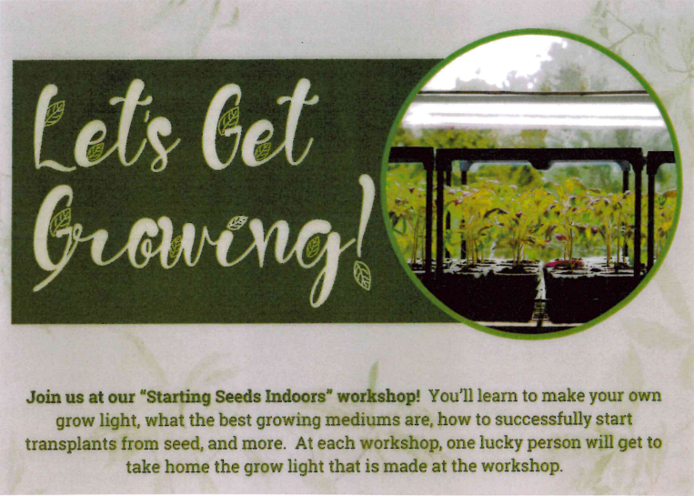

**“Starting Seeds Indoors” Workshop**

Thursday, February 29th

1:00 PM at the NCCC Chanute Cafeteria

Cleaver Family Dining Room Student Union 214

Free program. Join us after the Senior Lunch. Call Sandy at NCCC RSVP with questions 620.432.0422 or email [SHaggard@neosho.edu](mailto:SHaggard@neosho.edu)

